|  |  |
| --- | --- |
| Course Name | ITD-2313 Script Programming |
| Instructor | G. Morris |
| Student Name | Zane Fanelli |
| Due date | 2/4/2024 |
| Grade | <grade earned here> |
| Grading Comments | <instructor comments here> |

Scripting Projects Week 4

Project 4

Project 6

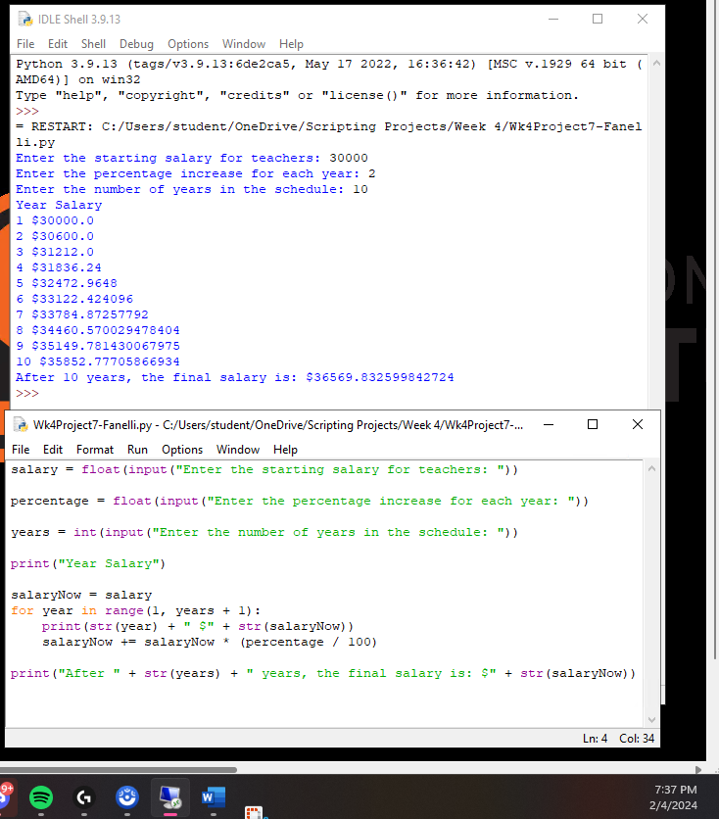Project 7